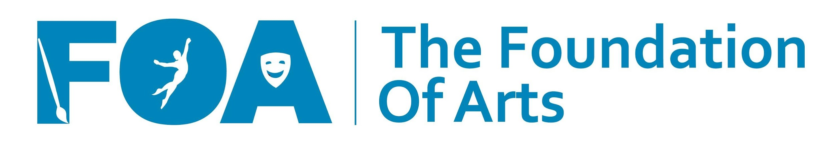September 15th, 16th and December 15th, 16th
What You Need To Know
Before You Audition for The FOA Music Show

Music Director Ken Wadley
Production Director Kristi Pulliam

Auditions Each auditioner should bring no more or less than 1 minute of a prepared song for the audition. They should also bring their own accompaniment. Focus will be on their vocal ability and their ability to perform the song with personality and panache. The recommended age for cast members is 12 years old and older, although the director reserves the right to cast younger children according to whoever best fits within this particular production. Please note the performance dates and do not audition if you cannot be present. Only come to one audition day.

Callbacks There will not be traditional callbacks.

Casting The cast list will be posted online at www.FOAjonesboro.org by next February 26th at 12:00 pm. Casting information will not be given early, and it won’t be given over the phone. All cast members will be required to attend a meeting that same day, Tuesday, February 26th at 5:30. (There will be a rehearsal scheduled after the meeting, too.) Please know that if you aren’t cast, there are future auditions for future productions! Once we have seen you, we are more aware of your skills and abilities, and you also have more insight into the auditioning process at The FOA.

Casting will be very selective. If you are auditioning with other family members today, you need to realize that we might not be able to cast all of you. Please, though, make a note on your audition form if you are auditioning with a family member. Also note if you are auditioning with someone who, if not cast, you will not accept your role.

Commitment Being cast in The FOA Music Show will require dedication and commitment. Each performer will be required to attend their rehearsals which will be schedule on several Saturdays over the next few months. Depending on the songs you’re cast in, you could be scheduled for several rehearsals per week in the final 8 weeks. Also, each performer will be required to stay 1 hour after the last performance to strike. This play is very demanding and requires that actors be focused and present. Please think about this very carefully before you agree to commit to this show.

As a cast member, you and/or your family will be required to volunteer a minimum of 4 hours for the show besides rehearsals. Many specific areas of volunteerism are needed, and a list will be provided if you are cast. Commitments for your volunteer work will be made at the cast meeting.
A complete rehearsal schedule will be provided at the cast meeting.

Tech/Tech Rehearsals This is the final two weeks of rehearsals right before the show opens. No one is allowed to miss a Tech rehearsal. If you are not inclined to appear onstage, but would like to volunteer on the project in another way, please complete an audition form telling us that, and bring it to auditions to give to the Director. You won’t have to audition for a role onstage☺

Production Fee Everyone who is cast in The FOA Music Show is asked to pay a $40.00 production fee which will help cover the cost of your costume, the scenery, your script, etc. You are welcome to consider this payment as a donation, and it is tax deductible, as allowed by the regulations of the Internal Revenue Service. NOTE: if this fee is a hardship on you or your family, it will be waived, no questions asked – simply speak to Kristi Pulliam if you need it to be waived. This fee will be due at the February 26th at the cast meeting.

Costumes The Foundation of Arts will provide some specialty costumes for this production; however, you will be asked to furnish some items (shoes, white t-shirts, jackets, etc). AT NO TIME will an individual actor be authorized to override a costumer’s design. Personal items (socks, panty hose, undergarments, etc.) will not be provided by The Foundation or Arts.

Make Up The Foundation of Arts provides specialty makeup only (for shows that include animal characters, sci-fi characters, etc.) Each actor will be asked to provide his/her own personal makeup (and hair products). All actors may be required to wear makeup for performances.

Props The FOA Music Show is full of great props!! Our cast will be encouraged to bring some of the props needed for the show, and your assistant director will tell you more about that at the cast meeting.

Performance Dates May 3rd, May 17th, 18th, and 19th

