Oasis Arts Festival 2019 Application
Dear Artist,
We are so excited to invite you to participate in the second annual OASIS Arts Festival in Jonesboro, Arkansas! This event is a collaborative effort between the Foundation of Arts, The Downtown Jonesboro Association, and The Dept. of Art + Design at Arkansas State University. OASIS is a celebration of the arts in Northeast Arkansas and open to any skilled artists or craftsmen who wish to apply. Art works will be exhibited outdoors along Main Street and other parts of downtown (area will be closed). We will also showcase performances by musicians, actors, dancers, and/or poets. All varieties of original visual art media may be displayed and sold, but no third party selling will be permitted. Each participant will be given a 10x10 space and must provide own tables, tents, easels, or any other set-up equipment they deem necessary.
EVENT DATE: May 4th, 2019 10:00-6:00 pm RAIN OR SHINE. This will be an all outdoor event if weather cooperates but in the event of rain, exhibits will be moved inside the FOA’s Forum Theatre and Stage Too venues. Because we are providing an inclement weather back up plan, no refunds will be given if an artist chooses not to participate.
REGISTRATION FEE:
- $50 for non-students
- $25 for college students* and any teachers
- $10 for high school students
*Must provide proof of current student ID at time of registration.
WHERE TO FIND OASIS UPDATES:
- Follow us on fb @ oasisartsfest
- Follow us on Instagram @ oasisartsfest
- Visit foajonesboro.org or email us @ oasisartsjonesboro@gmail.com
We look forward to hearing from you and seeing your beautiful work!
Please fill out and return to the OASIS committee: 115 E. Monroe Jonesboro, AR 72401, Attn OASIS Arts Fest OR email to oasisartsjonesboro@gmail.com. Applications are due March 1st. Committee will review applications and notify artists accepted to festival by March 31st.
Name: _________________________________
Age: __________
Address: _______________________________
Email: _________________________________
Phone: _____________________
Artist Bio: ________________________________________________________________________________________________________________________________________________________________________________________________________________________________________________________________________________________________
VISUAL ARTISTS
What type of art will you be displaying?_____________________________________
Please submit 3-5 examples of your work to oasisartsjonesboro@gmail.com. This may be in the form of image attachments or a social media/online portfolio link.
PERFORMING ARTISTS
What type of art do you do? _________________________
How long will your performance last? ________________________
Do you perform solo or in a group? If group, how many members? _____________________
Please send a 1 min. video sample of your work to oasisartsjonesboro@gmail.com.
OASIS T-SHIRT
This year, OASIS participants will be given the option to purchase an event shirt! T-shirt orders and payment can be made along with regisration fees by March 31st.
Available sizes: Adult S-3XL Cost: Approx $25
Design:
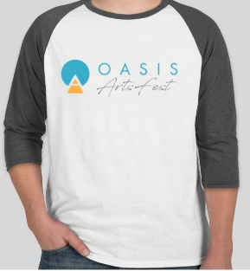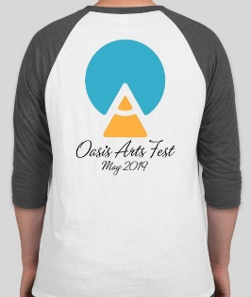
Would you be interested in ordering? Y N

